**TERM – SUMMER 2023**

| **Course & Section Code:** | **DBS501** |
| --- | --- |
| **Course Name:** | **Procedure Using Oracles PL/SQL** |
| **Course Start & End Dates:** |  |
| **Q&A / Virtual Office Hour:** | **6:30 PM – 9:30 PM** |
| **Instructor Name & Email:** | **Ersan Cam: ersan.cam@senecacollege.ca** |

Lab#10 (Triggers)

**Task1:**

USE LargeCo_ORA_Simplified script to build database…

USE **LG_XXXXX** tables for Task 1 and 2

1. **Write a trigger to update the customer balance when an invoice is deleted from LGINVOICE table. Name the trigger trg_updatecustbalance**

Hint: In Trigger body, update LGCUSTOMER for (WHERE) cust_code = : old.cust_code

Cust_balance must be equal to cust_balance- old.inv_total

|  |
| --- |
| create or replace trigger trg_updatecustbalance  after delete on lginvoice  for each row  begin  update lgcustomer  set cust_balance = cust_balance - :old.inv_total  where cust_code = :old.cust_code;  end;    Test case  Before deleting invoice |

**Task#2**

1. **Create a trigger named trg_line_prod that will automatically update the product quantity on hand (**P_QOH ) in PRODUCT TABLE **for each product sold after a new LINE row is added(inserted) to LGLINE table.**

Hint: (just high level coding. Do not quote on me )

In Trigger body, update LGPRODUCT for (WHERE) Prod_SKU = :NEW.Prod_SKU;

And calculate PROD_QOH = PROD_QOH – new quantity

**Task#3: (Use HR_XXX tables)**

**Preparation for Task #3**

Please build this procedure and insert a new record with this procedure

**Step1b:**

CREATE OR REPLACE PROCEDURE new_job

( p_jobid IN jobs.job_id%TYPE, p_title IN jobs.job_title%TYPE, v_minsal IN jobs.min_salary%TYPE)

IS

v_maxsal jobs.max_salary%TYPE := 2 * v_minsal;

BEGIN

INSERT INTO jobs(job_id, job_title, min_salary, max_salary) VALUES (p_jobid, p_title, v_minsal, v_maxsal);

DBMS_OUTPUT.PUT_LINE ('New row added to JOBS table:'); DBMS_OUTPUT.PUT_LINE (p_jobid || ' ' || p_title ||' '|| v_minsal || ' ' || v_maxsal);

END new_job;

**Step1b: to execute procedure to insert new record.**

Please replace single quote ‘ ‘ from Word to your SQL Developer

EXECUTE new_job (‘SY_ANAL’, ‘System Analyst’,6000)

This will create a new JOB_ID in JOBS table. So you can use this for Task 2

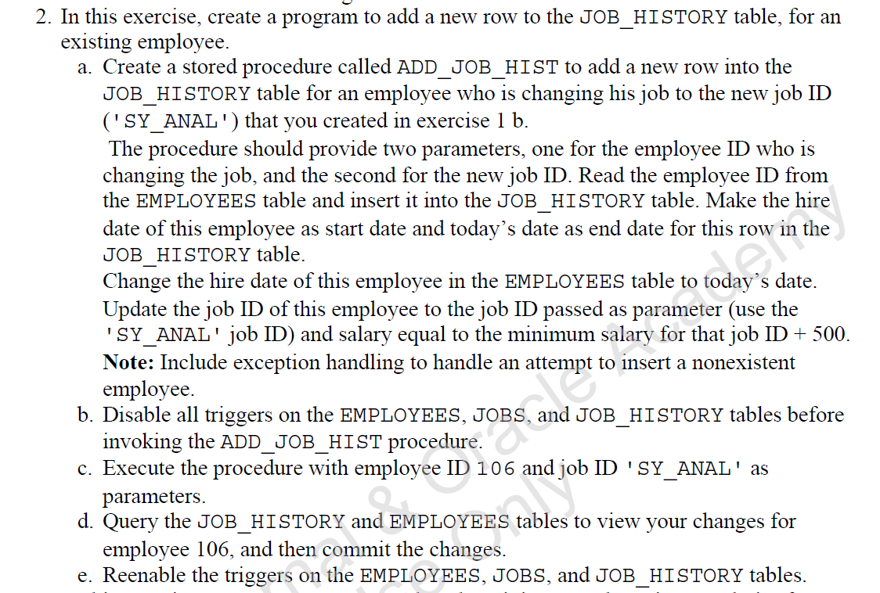

**Commands for 2-b (given for you)**

ALTER TABLE employees DISABLE ALL TRIGGERS;

ALTER TABLE jobs DISABLE ALL TRIGGERS;

ALTER TABLE job_history DISABLE ALL TRIGGERS;

**Commands for 2-e (Given for you)**

ALTER TABLE employees DISABLE ALL TRIGGERS;

ALTER TABLE jobs DISABLE ALL TRIGGERS;

ALTER TABLE job_history DISABLE ALL TRIGGERS;